VPC TASKS
Create VPC with 2 private and 2 public subnets.

Logon to aws console
Go to vpc services
created vpc with name my-first-vpc
created 2 public subnets and 2 private subnets.
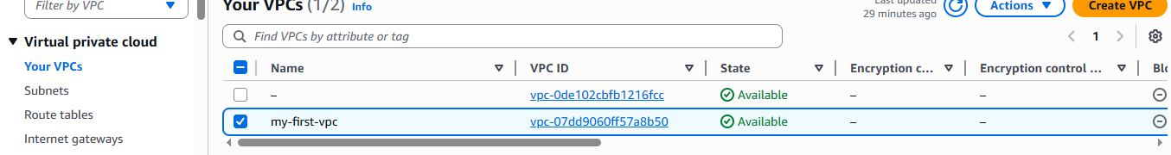

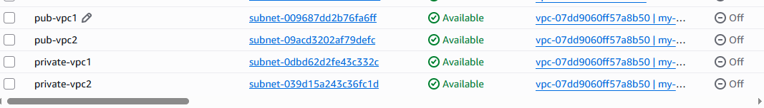

Enable DNS Hostname in VPC.

Go to aws console
Go to vpc
Go to actions
Select edit vpc settings
Go to DNS settings and check the Enable DNS hostnames
Save the changes
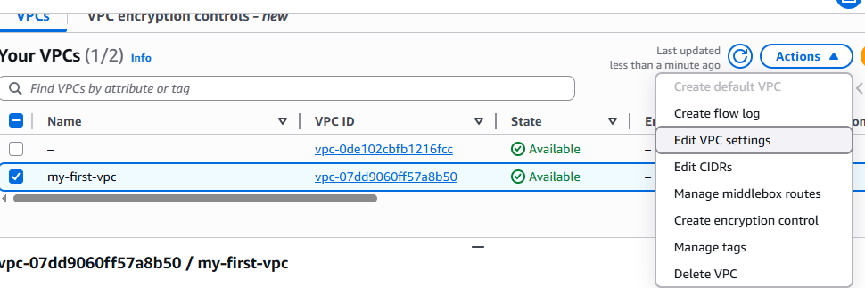
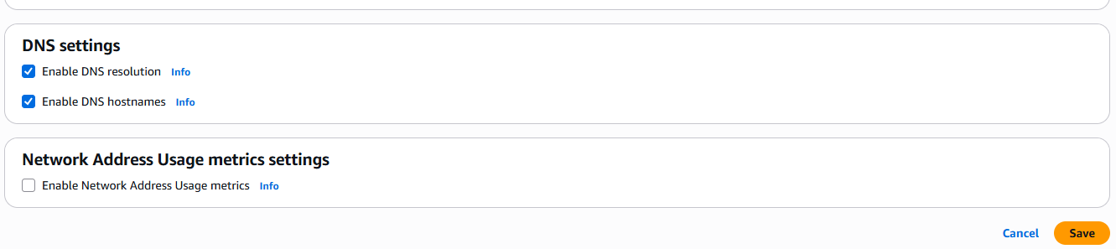

Enable Auto Assign Public IP in 2 public subnets.

Go to aws console
Go to vpc service
Go to subnets
Select the public ip
Go to actions and edit the subnet settings
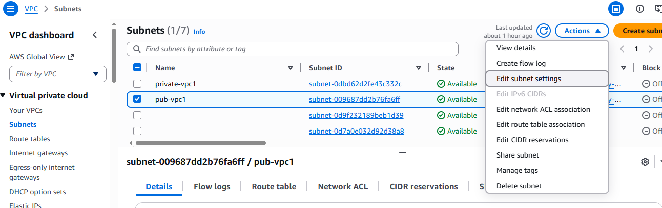
Check the auto assign ip settings
Save the changes
Same repeat for second public ip

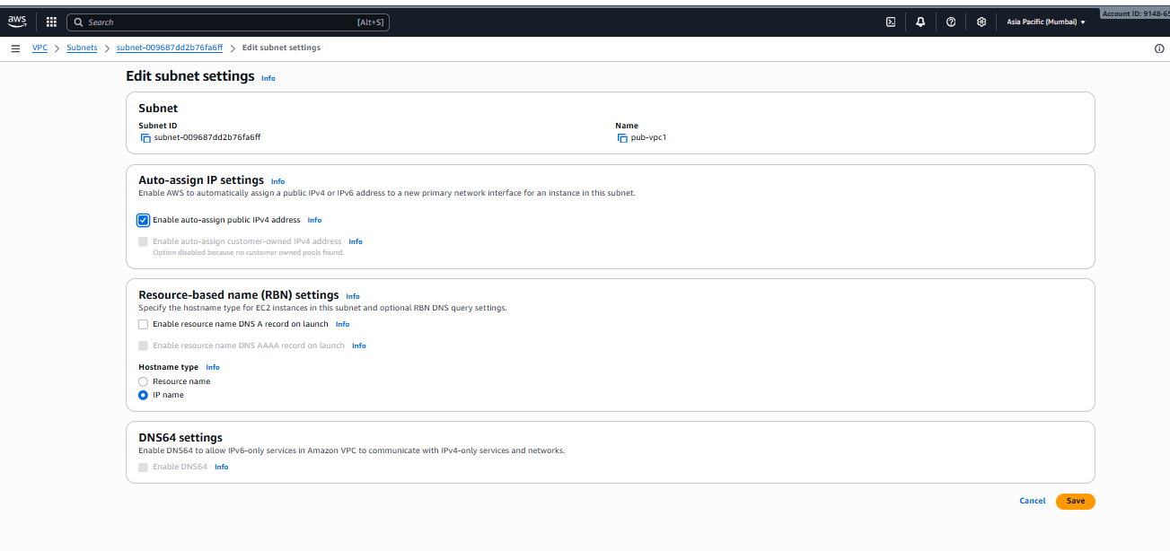

Add 2 private subnets in private route table.

Go to aws console
Go to vpc service
Select Route Tables
Create route table
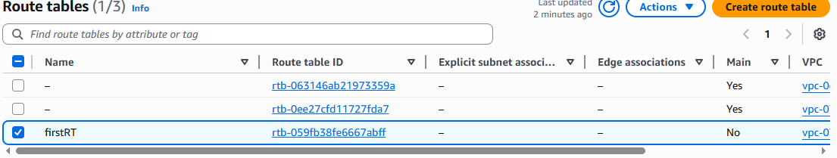

After creating route table go to actions and edit the subnet associations
Select the subnets of private and save the associations
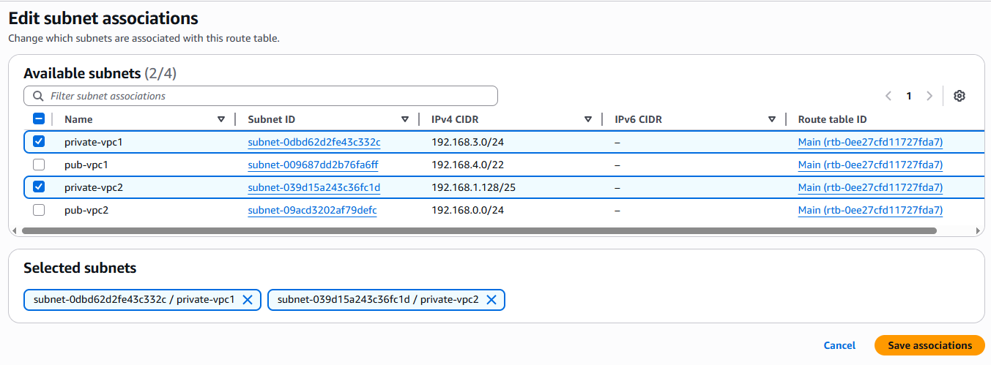

Add 2 public subnets in public route table.

Go to aws console
Go to vpc service
Select Route Tables
Create route table
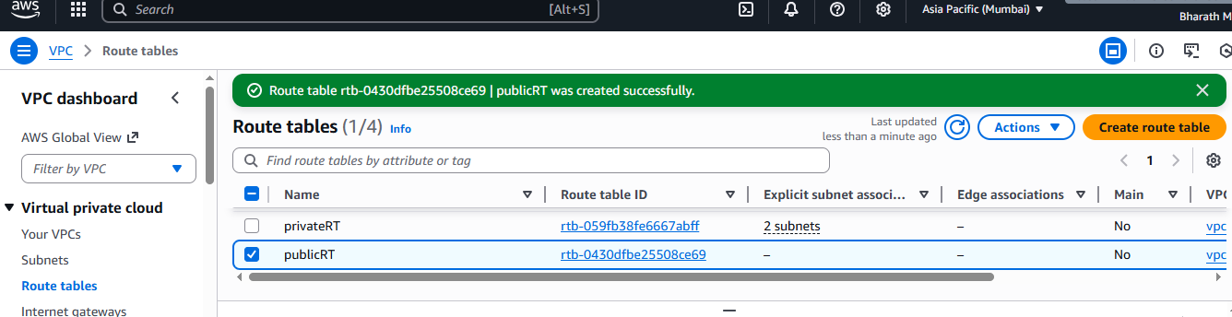

After creating route table go to actions and edit the subnet associations
Select the subnets of public and save the associations
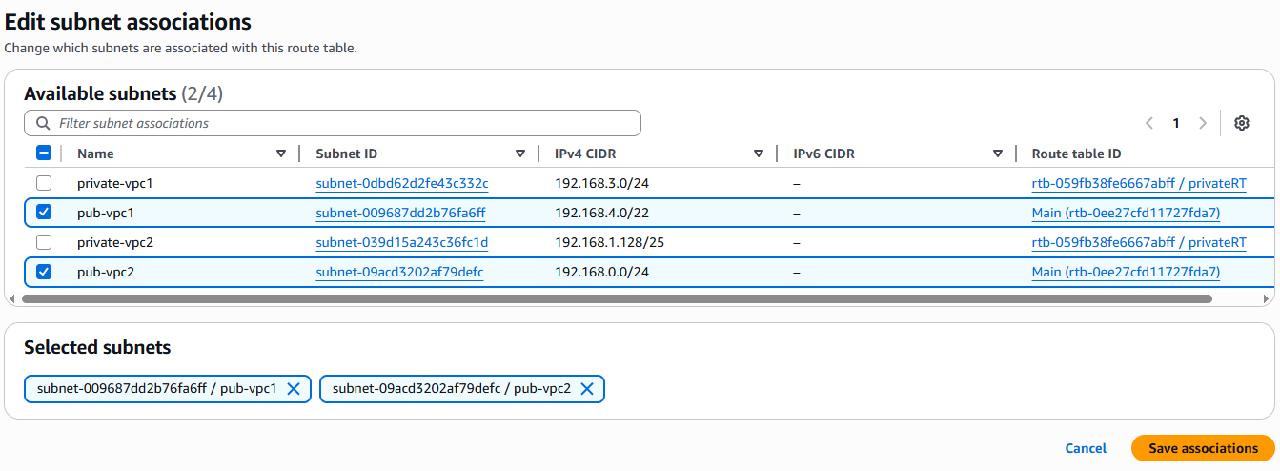

Public route table will have the routes to internet and local.

Go to aws console
Go to vpc service
Go the internet gateway
Create internet gateway

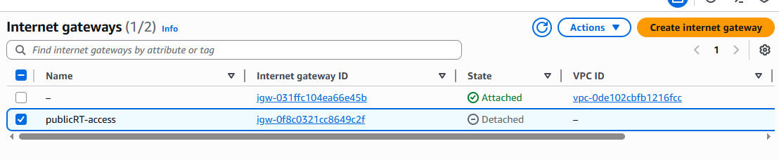
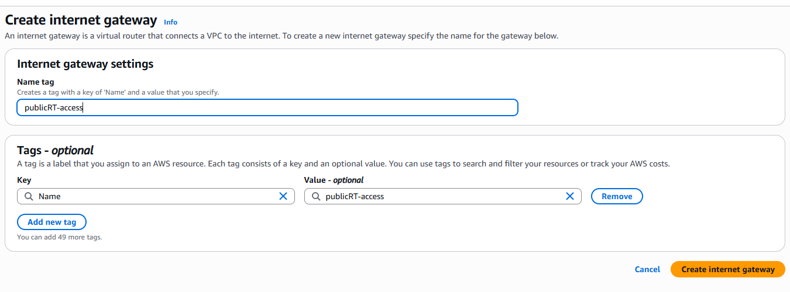
Attach Vpc to internet gateway
Come back to the Route tables and select the public created route table
Go to actions and edit routes
Add routes destination to 0.0.0.0/0 and target to internet gateway.
Select the publicRT and save the changes.

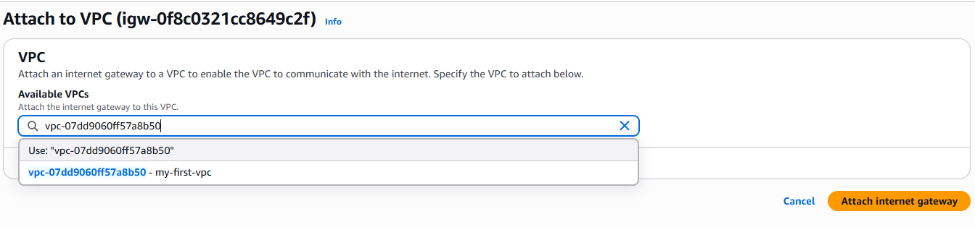
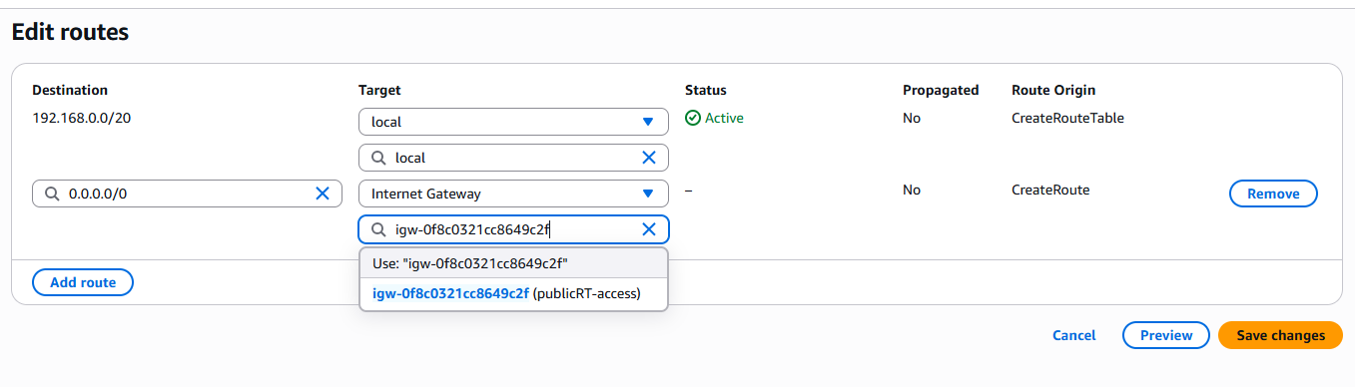

Create EC2 in public subnet with t2.micro and install PHP.

Launch the instance in aws console
Edit the network settings while launching the instance
Select vpc and public id
Select the security group or create one security group
Launch the instance.
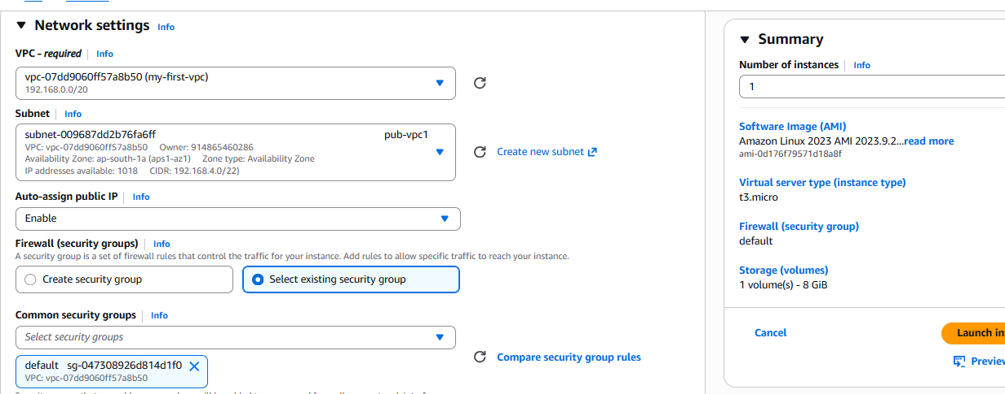
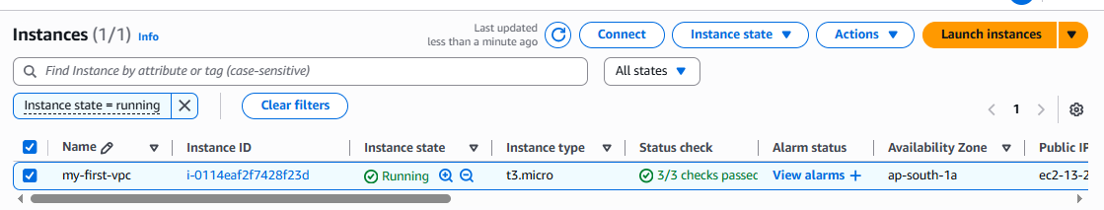
Connect to instance.
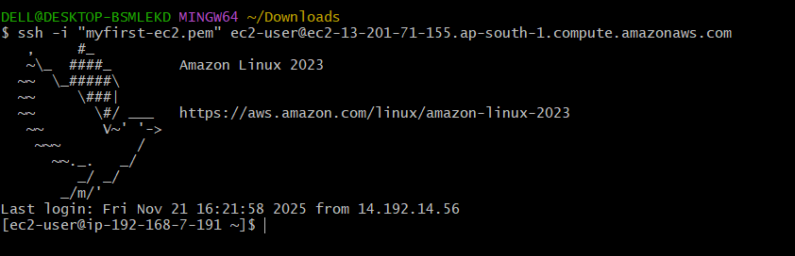
update the packages “yum update -y”
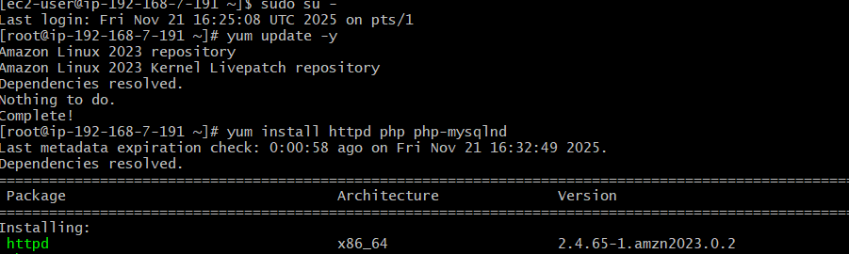
install the httpd and php “yum install httpd php “
start the service “systemctl start httpd”
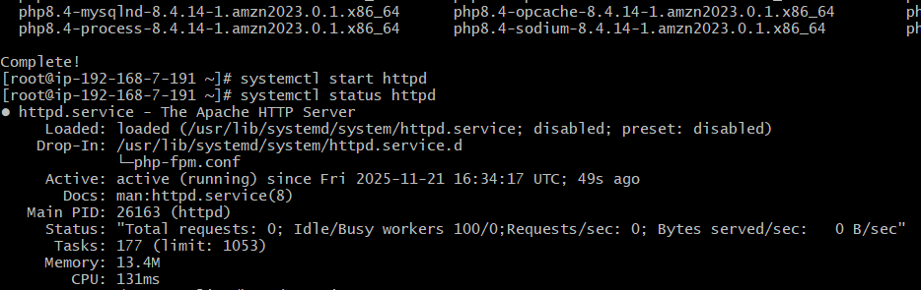

Configure NAT gateway in public subnet and connect to private instance.

Create a VPC
Log in to the AWS Management Console → Navigate to VPC → Create VPC.
Configure:
Name tag: MyVPC
IPv4 CIDR block: e.g., 10.0.0.0/16
Tenancy: Default
Click Create VPC.

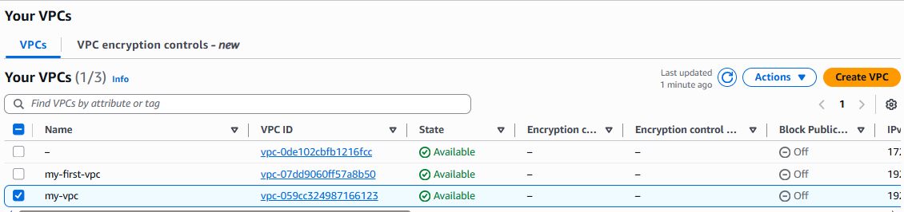
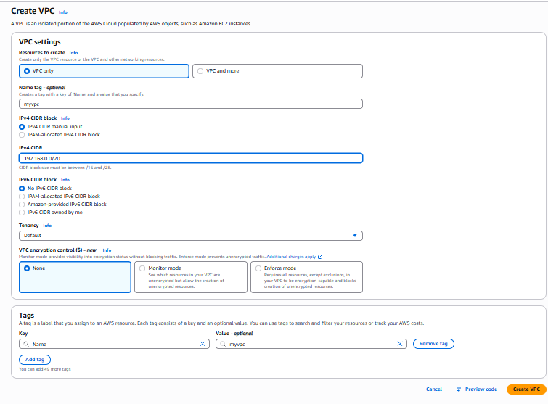

Create Subnets
Public Subnet (for NAT Gateway & optionally bastion host):
Name: PublicSubnet1
IPv4 CIDR: 192.168.0.1/24
Assign auto-assign public IP for instances.
Private Subnet (for internal instances):
Name: PrivateSubnet1
IPv4 CIDR: 192.168.0.2/24
No public IP assignment.

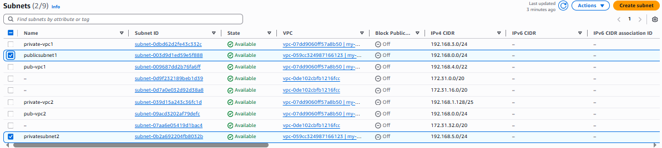
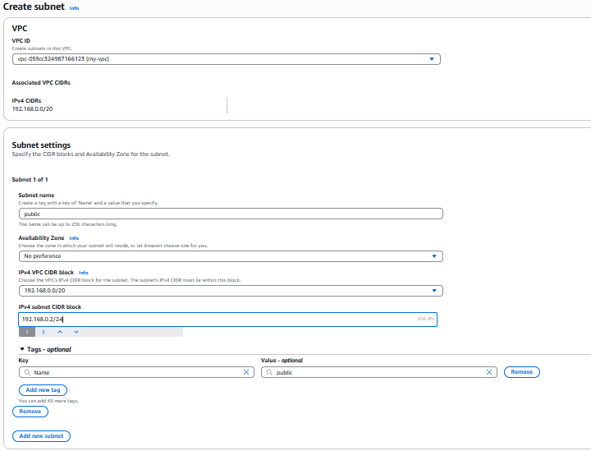
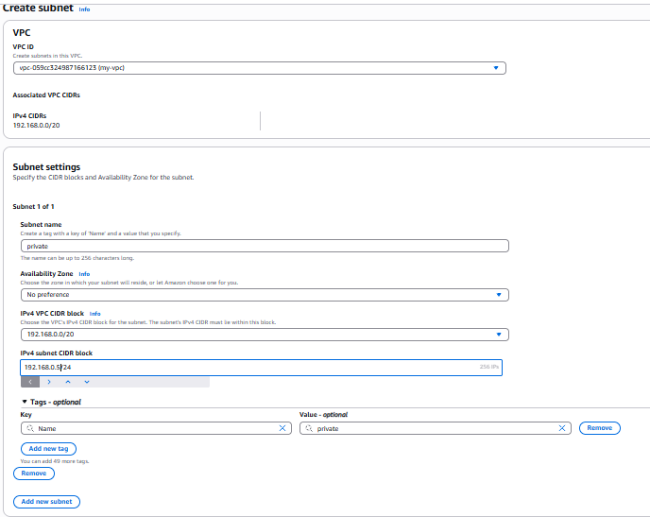

Set Up Internet Gateway
Go to Internet Gateways → Create Internet Gateway, name it MyIGW.
Attach the IGW to the VPC created earlier. In actions field we can find attach VPC
Create two route tables public and private
Update the route table for the Public Subnet:
Destination: 0.0.0.0/0 → Target: Internet Gateway (IGW).

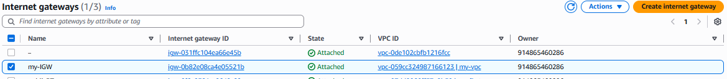

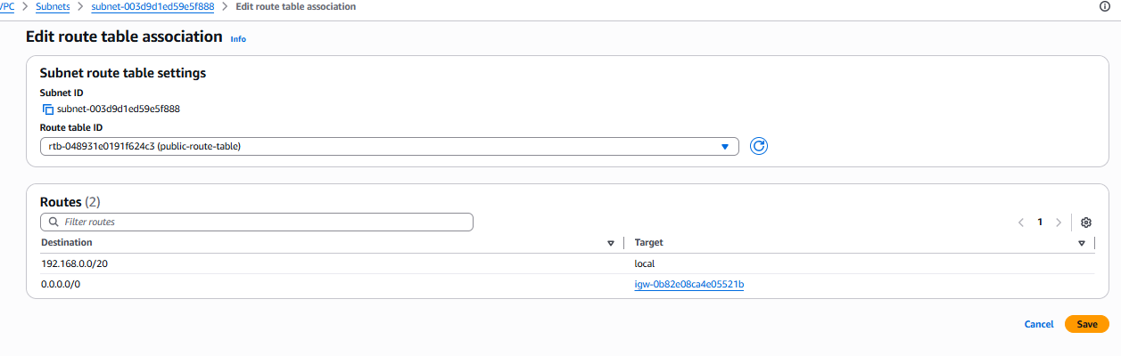

Create NAT Gateway in the Public Subnet
Go to NAT Gateways → Click Create NAT Gateway.
Configure:
Subnet: PublicSubnet1
Elastic IP: Allocate new or choose existing.
Click Create NAT Gateway and wait for its status to be available.

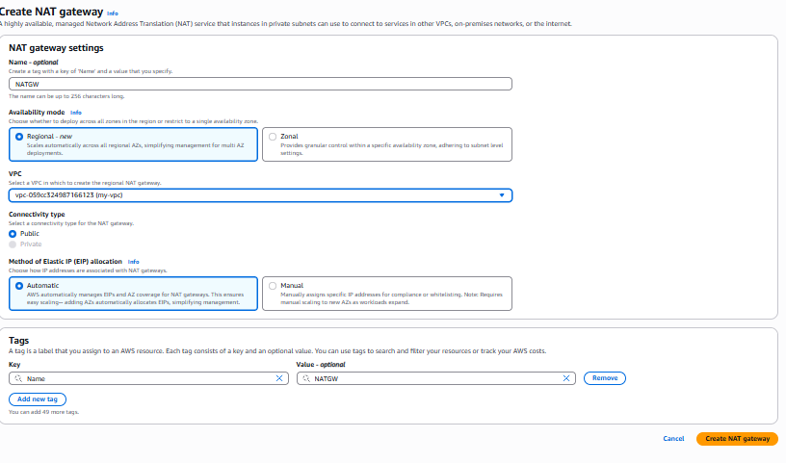
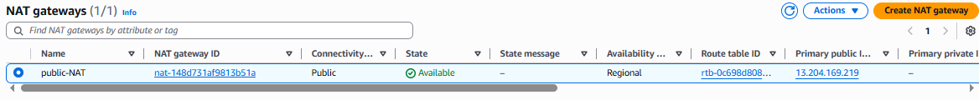

Configure Route Table for Private Subnet
Go to Route Tables → Select the route table for PrivateSubnet1.
Edit routes:
Add route: Destination 0.0.0.0/0 → Target NAT Gateway
Associate the private subnet with this route table.
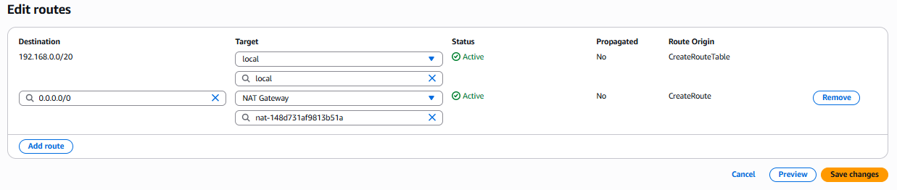

Launch EC2 Instances
Public Instance (optional for SSH/Bastion):
Subnet: PublicSubnet1
Auto-assign public IP: Enabled
Security Group: Allow SSH (port 22) from your IP.
Private Instance:
Subnet: PrivateSubnet1
Auto-assign public IP: Disabled
Security Group: Allow outbound traffic to internet via NAT.

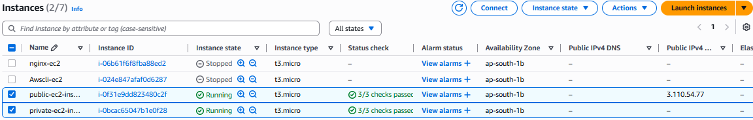
SSH into the bastion host in the public subnet.
Create on file in public instance and do copy & paste of pemkey and save
So that we can access to private instance from public instance
From the bastion host, SSH into the private instance.

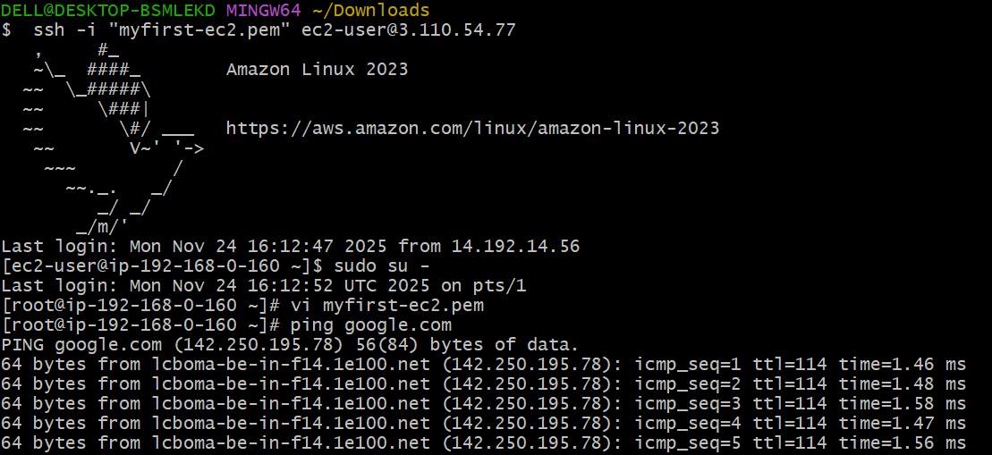

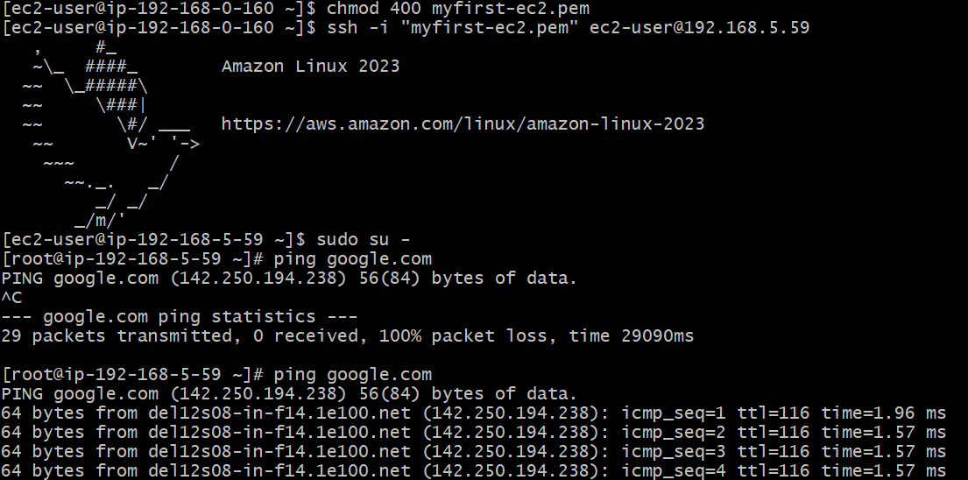

Install Apache Tomcat in private EC2 and deploy a sample app.

Connect to the private instance and update the packages.

Install java by using “yum install java”

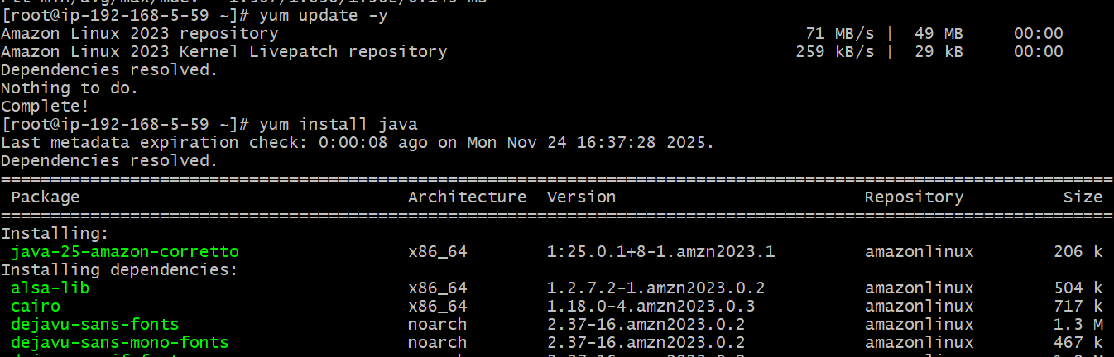

Go to ‘opt’ directory
By using “wget” command download the Apache Tomcat tar file link.
To extract the tar file use the command ‘tar xvf apache-tomacat’
After extracting, go to apache-tomcat directory
There we can find webapps directory in webapps directory download one sample war file by using command ‘wget sample.war file URL’
Extract the sample.war file for deployment of war file.
Come outside form webapps directory and change the directory to bin.
In bin directory we can start the tomcat service by using ‘./startup.sh’
Tomcat service started.

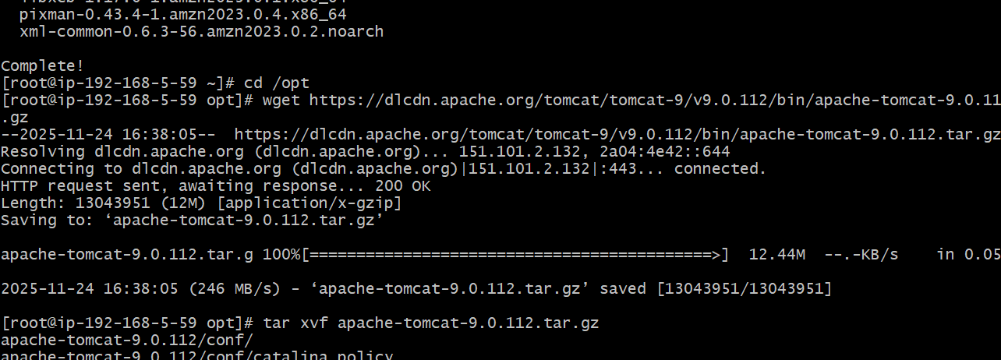

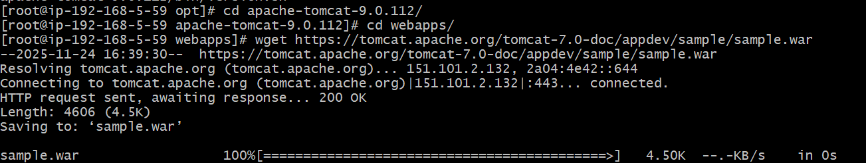

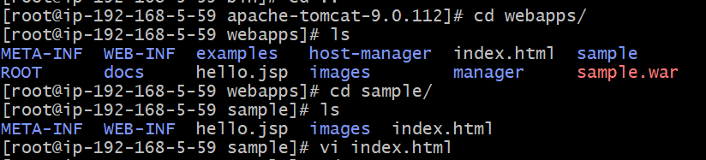

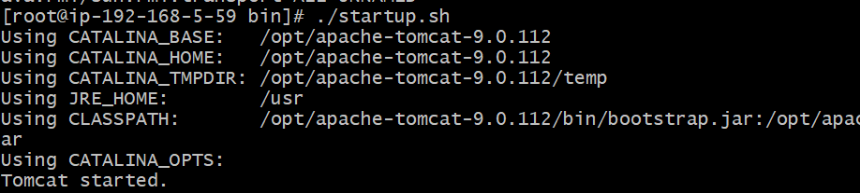

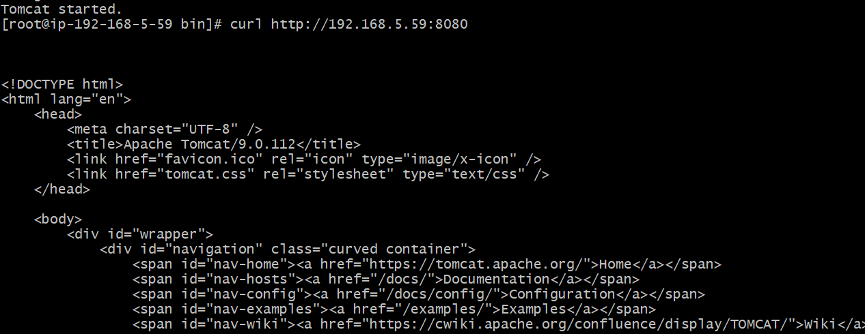

Configure VPC flow logs and store the logs in S3 and CloudWatch.

Store in s3:
Go to aws console
Go to vpc service
Create flowlog
Before creating flow log generate s3 bucket ARN
Paste that ARN while creating a flow-log
Create flowlog

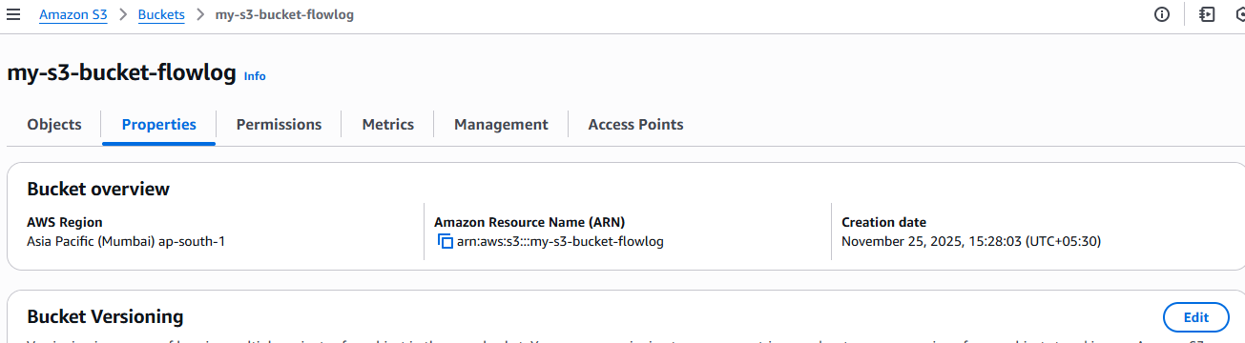
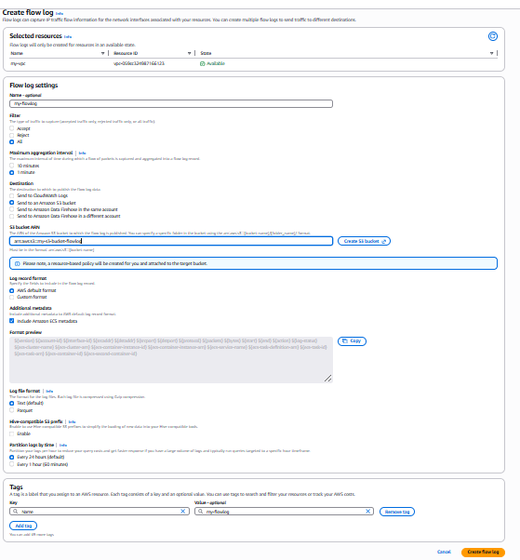
Go to s3 service we can find the flowlogs
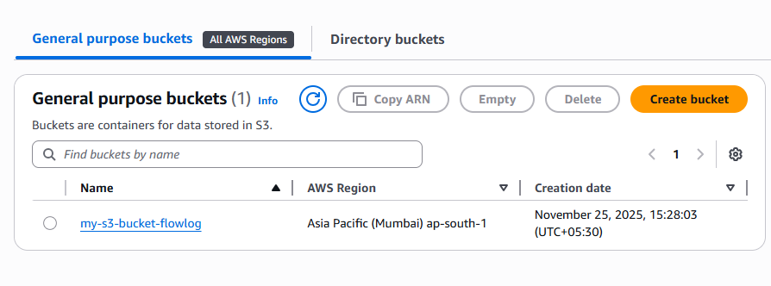

Going inside the flow log we can see the instance logs.
We can download and extract and see all the logs of particular log.
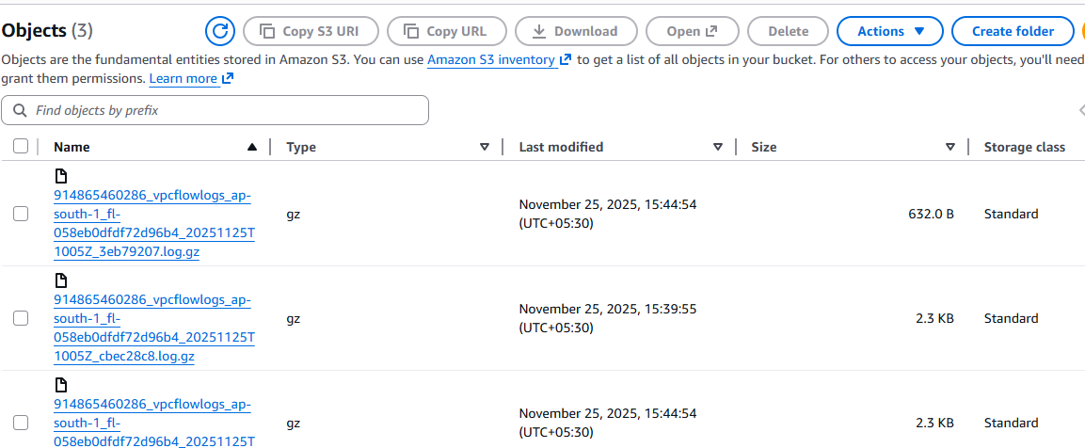

Flowlog using cloud watch:

Go to console
Go to vpc
Create flowlog
Crate cloudwatch logs before creating flowlog in vpc
Create IAM roles and trust policies

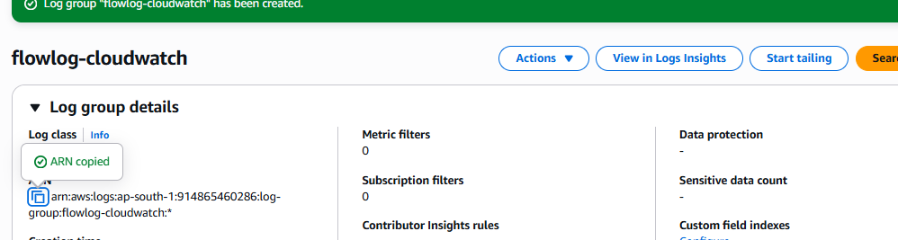

in vpc flowlog give the destination of cloudwatch
give the IAM role name in the service role section.
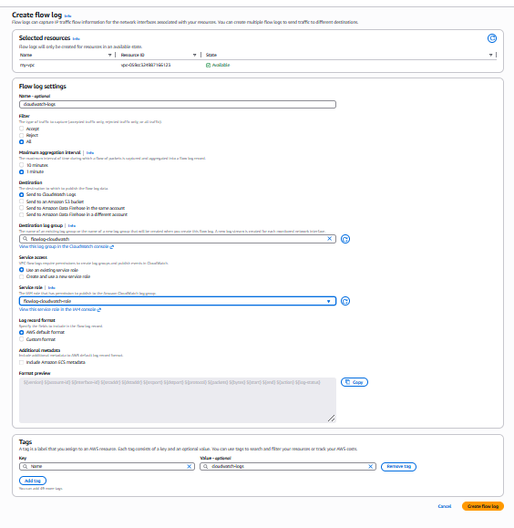
Create flow log
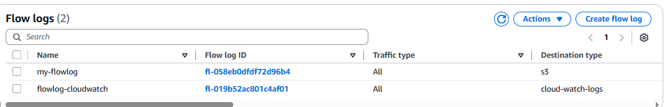

Go to the flowlog of cloudwatch we can find all the logs of aws
